# **Lab Manual 5**

**Question 1:**

**Note:**

1. You have to use x-path axes where applicable.
2. Use Explicit waits (Check whether the elements are clickable or not).
3. Use action Class to scroll down the pages.

Step 0:

Go to site: <https://omayo.blogspot.in/>

And explore this site.

Step 1(Verify Input Value by using Assertions):

Fill these two text fields

1. Enter your name in first Text field.
2. Get the data written in text field two, then clear it and at last write a line to give a description about your personality.

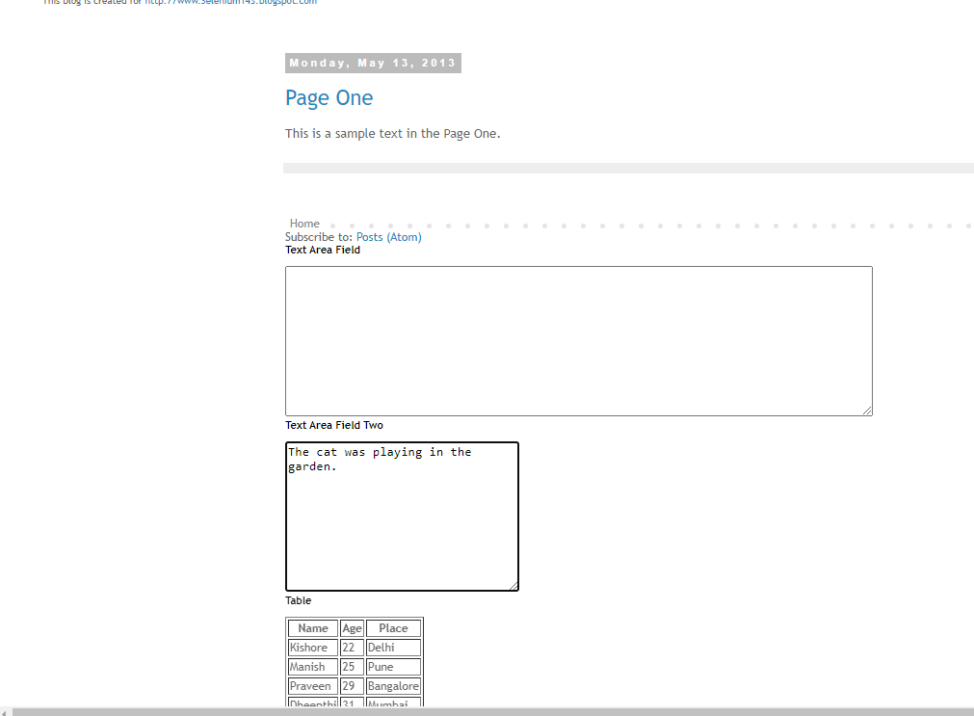

Step 2:

Get the Data from table. And print it on the console.

Note: Use List of Web Elements if possible. And read

<https://www.guru99.com/selenium-webtable.html>

<https://www.guru99.com/handling-dynamic-selenium-webdriver.html>

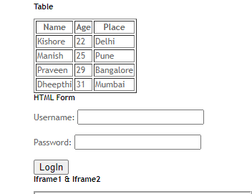

Then Enter username and Password and hit login button.

Step 3 (Use Assertions):

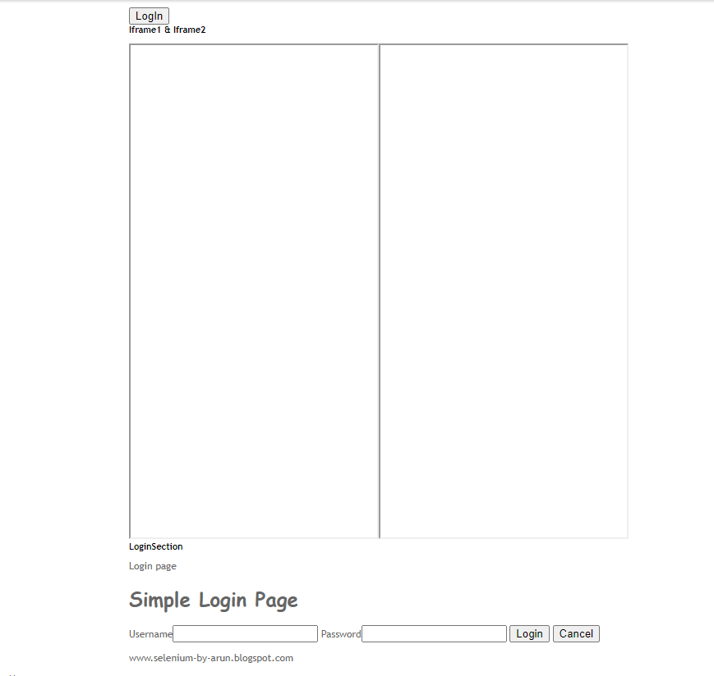

Switch to both frames one by one.

Then enter username and password, then hit the login button.

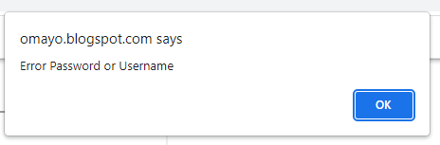

An alert will appear on the top of your screen. Handle that alert.

Step 4:

Select Hyundai and select doc3 as shown in picture.

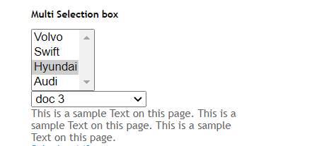

Clear the preloaded text box and enter hello world

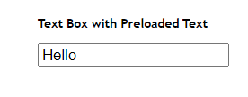

Lick on enables button

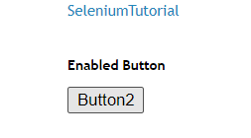

Try clicking all three buttons

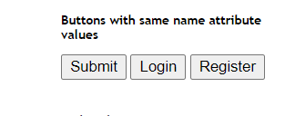

Click on this button and handle alert

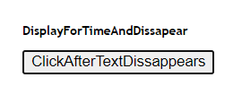

Click on Open Popup window

And get the text written on the pop up window



Click on try it button

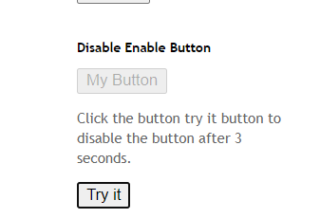

Now double click on the button ‘Double click here’ and handle alert

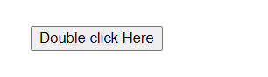

Then click on check this button and wait for the Mr. option to get enabled and click it.

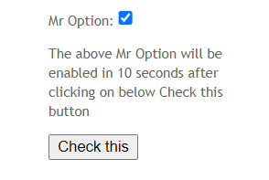

Step 5:

Now, Select your gender, click on the button ‘ClickToGetAlert’ handle alert

Select color blue an deselect orange.

‘ReadThisText’ from text box

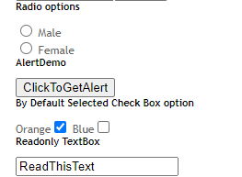

Click on ‘GetPrompt’, then click on getConfirmation

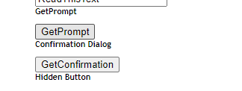

Fill the text boxes below and then select car.

Select bag and book and deselect the book.

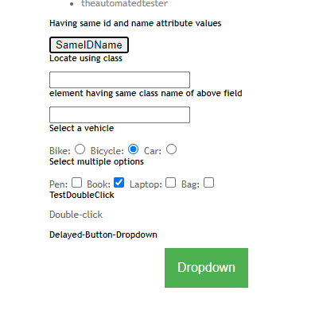

Double click on the ‘Double-click’ or click on the green dropdown button and select one option.